Spring Semester 2026
This course syllabus is subject to modification by the instructor during the semester.

Course Information

Course: BIOL 369 Principles of Human Nutrition
Credit Hours: 3
Professor: Dr Michael A. Winrow
Phone: 252-335-3794
Email: mawinrow@ecsu.edu
Office Location: 422 Jenkins Science Center
Office Hours: Refer to Canvas

Course Format / Location

- Face to Face – Course meets face to face all the time; all students expected to be in class each day.
- Time and Course Location: MWF 2:00 pm – 2:50 pm
- Room 102 Jenkins Science Center

Course Description

General Description: This course provides students with an understanding of the fundamental concepts of human nutrition. Special emphasis is placed on the roles of carbohydrates, proteins, lipids, vitamins, minerals, and metabolism as they relate to human health and disease.

Learning Outcomes:
- Classify macronutrients and micronutrients and identify common functions and
food sources of each.
- Describe the recommended levels of intake of macronutrients and micronutrients
and how these change through the lifespan and during illness.
- Explain how macronutrients and micronutrients are used in physiological
processes.

Course Requirements

Required Text(s) and Materials: Nutrition for a Changing World: Dietary Guidelines for Americans 2020-2025 & Digital Update 2ed|2022 Jamie Pope; Steven Nizielski

Computer Requirements:
  - Access: Students will need access to a computer with internet connection.

Course Grading Components

Assignment | Percent of Final Grade
- Examination | 65
- Homework | 20
- Final Exam | 15

Grading Scale [Insert detailed listing of grading scale]: The Grading Scale is consistent with university policy and is as follows:
100-90 = A 89-80 = B 79-70 = C 69-60 = D Below 60 = F

Course Outline
In-Person Class time is for:
1) Exam and quizzes
2) Expanding on the textbook to include newer and more advanced information
3). Getting an overview of major concepts, minor points, and how they fit together.
4) Asking and answering questions
5) Possible Guest speakers

Possible online activities:
1) Possible quizzes
2) Videos that provide more example of key concepts

Course Outline:
Spring 2026 Schedule
Monday | Tuesday | Wednesday | Thursday | Friday
1/12 | 1/13  First Day of Classes | 1/13  Intro to Course  Chapter 1  Nutrition and You | 1/15 | 1/16  Chapter1  Nutrition and You
1/19  Martin Luther King Jr. Day | 1/20 | 1/21  Chapter 2  Achieving a Healthy Diets | 1/22 | 1/23  Chapter 2  Achieving a Healthy Diets
1/26 Chapter 2 Nutrition and the Human Body | 1/27 | 1/28 Chapter 3 Nutrition and the Human Body | 8/29 | 1/30 Chapter 3 Nutrition and the Human Body
2/2 Chapter 3 Nutrition and the Human Body | 2/3 | 2/4 Exam 1 | 2/5 | 2/6 Chapter 4  Carbohydrates
2/9 Chapter 4  Carbohydrates | 2/10 | 2//11 Chapter 5  Lipids | 2/12 | 2/13 Chapter 5 Lipids
2/16 Chapter 6 Lipids | 2/17 | 2/18 Chapter 6 Proteins | 2/19 | 2/20 Chapter 6 Proteins
2/23 Exam 2 | 9/24 | 2/25 Chapter 7  Fat Soluble Vitamins | 2/26 | 2/27 Chapter 7  Fat Soluble Vitamins
3/2 Chapter 7  Fat Soluble Vitamins | 3/3 | 3/4 Chapter 8  Water-Soluble Vitamins | 10/5 | 3/6 Chapter 8  Water-Soluble Vitamins
3/9 Chapter 9  Major Minerals and Water | 3/10 | 3/11 Chapter 9  Major Minerals and Water | 3/12 | 3/13 Chapter 9  Major Minerals and Water
3/16  Spring Break | 3/17  Spring Break | 3/18 Chapter 10  Spring Break | 3/19  Spring Break | 3/20 Chapter 10  Spring Break
3/30 Chapter 10  Trace Minerals | 3/31 | 4/1 Chapter 11  Trace Minerals  10/8 Energy Balance and Obesity | 4/2 | 4/3 Chapter 12  Good Friday Holiday
4/6 Chapter 12  Easter Monday | 4/7 | 4/8 Chapter 12  Trace Mineral  Nutrition and Fitness | 4/9 | 4/10  Energy Balance and Obesity
4/13  Energy Balance and  Obesity | 4/14 | 4/15 Chapter 13  Energy Balance and Obesity | 4/16 | 4/17 Chapter 13  Nutrition During the College Years
4/20 Chapter 13  Nutrition During the College Years | 4/21 | 4/22  Chapter 13  Nutrition During the College Years | 4/23 | 4/24  Exam 4
4/27 Chapter 14:  Chapter 14 Global Nutrition Food Security and Sustainability | 4/28 | 4/29  Chapter 14 Global Nutrition Food Security and Sustainability | 4/30 | 5/1 Chapter 15  Last Day of Class  Chapter 14 Global Nutrition Food Security and Sustainability
5/4  Final Exams | 5/5  Final Exams | 5/6  Final Exams | 5/7  Final Exams | 5/8  Final Exams

Expectations for Students
- Check Canvas often.
- ATTENDANCE POLICY
1. Regular and punctual class attendance is essential to each student’s class
performance.
2. Absence from class for any reason does not free the student from responsibility for
material covered during missed classes. It is the student’s responsibility to make
arrangements for missed instruction.
Students who are unable to attend class for a valid reason should contact VikingSuccess@ecsu.edu to receive a reasonable accommodation
Absent urgent circumstances, faculty members will respond to emails the next business day.
3. Should you exceed the allowable number of absences; I have the option of informing the student that a grade of “F” will be turned in at the end of the semester. You may wish to officially withdraw from the class. No additional absences shall be allowed except for the most severe circumstances.
4. Punctuality being an important component of any class; students are expected to be on time to every class. Consequences for consistent late arrival and leaving the class early should be covered in the course syllabus. Instructors may record excessive lateness or early departure from class as an absence.
ABSENCES ALLOWED FOR THIS COURSE: 4

Course Policies
- Late Assignments: Ten points each day is late.
- Missed Assignments zero score for missed assignment or exam

- Netiquette Guidelines
  - Write in digestible chunks. Lengthy paragraphs are difficult for readers to digest. Keep your paragraphs short and your writing concise.
  - NO YELLING. When you write in uppercase letters in online communication, it is usually
  - interpreted as yelling.
  - Add some emotion :-). Sometimes it helps communicate the tone of your message when you add an emoticon or emoji. However, only do so as necessary, for it can end up being annoying to readers if you have too many, which is probably the opposite of your intention.
  - Use humor carefully. Sarcasm, in particular, does not translate well in an online environment. It’s best to avoid the potential pitfalls of misunderstood messages.
  - Assume the best intentions. In an online environment, it is easy to misread someone’s tone or intended message. Give your peers and instructor the benefit of the doubt, and ask them to clarify their meaning.
  - We are not the same. Respect differences, and don’t make assumptions.

Language matters. Choose your words carefully; avoid using slang, and be kind. University Policies

Policy on Academic Honesty:
As members of the academic community, students are expected to recognize and uphold standards of intellectual and academic integrity. The examples and definitions given below are intended to clarify the standards by which academic honesty and academically honorable conduct are to be judged. The following list is merely illustrative and is not intended to be exhaustive.

- PLAGIARISM. Plagiarism is presenting another person’s work as one’s own. It includes paraphrasing or summarizing the works of another person without acknowledgement, including submitting another student’s work as one’s own.

- CHEATING. This involves giving or receiving unauthorized assistance before, during or after an examination.

- UNAUTHORIZED COLLABORATION. Submission for academic credit for a work, product or a part thereof, represented as being one’s own effort that has been developed in substantial collaboration with or without assistance from another person or source is a violation.

- FALSIFICATION. It is a violation to misrepresent material or fabricate information in an academic exercise or assignment.

- MULTIPLE SUBMISSIONS. It is a violation of academic honesty to submit substantial portions of the same work for credit more than once without the explicit consent of the instructor(s) to whom the material is submitted for additional credit. In cases where there is a natural development of research or knowledge in a sequence of courses, use of prior work may be desirable or even required.

Policy on Limitations of Course Withdrawals (300.1.26)
- Maximum Course Withdrawal (Semester Hours): Students can drop classes without penalty during the schedule change (drop/add) period at the start of the semester. Schedule change deadlines are published in the academic calendar. After the drop/add deadline, students can withdraw from no more than 15 semester hours during their undergraduate career. After a student has exceeded this limit, the student must receive a final grade of A, B, C, D, or F. Incompletes “I” will not be allowed as a substitute for a course withdrawal beyond the course withdrawal limit. The course withdrawal limit applies to first-time college students and follows them until they graduate. Current and returning students are not affected. Any course that a student drops is counted toward the 15 semester hour limit.

- Transfer Students: Regardless of the number of colleges a student may have attended, the number of classes they may have taken, or the number of years they enroll as undergraduates, the policy limits them to 15 semester hours of course withdrawals. This includes any course a transfer student has dropped at another institution of higher education.

ADA Syllabus Access Statement
All Accommodations
Elizabeth City State University provides accommodations to students with documented disabilities. In post-secondary school settings, academic accommodations are not automatic.

If you are a person with a disability and anticipate needing accommodations of any type in order to participate in this class, you must make a formal request for services through the Office of Student Accessibility & Testing Services Office (117 CW Griffin Bldg., 252-335-3642), and provide necessary documentation of disability by a qualified professional.

Communications with the Office of Student Accessibility and Testing are confidential. Once accommodations are approved, your professor will be notified, and approved accommodations will be implemented.

Note: Approved accommodations are not retroactive.

Additional information regarding the accommodation process can be found https://www.ecsu.edu/current-students/student-affairs/student-accessibility-and-testing-services/forfacultystaff.html

ECSU Credit Hour Policy 300.1.25)
Per the ECSU Credit Hour Policy provided this course is worth 1 credit hour that means in a normal 16-week semester you would complete 3 hours of work a week related to that 1 credit hour.

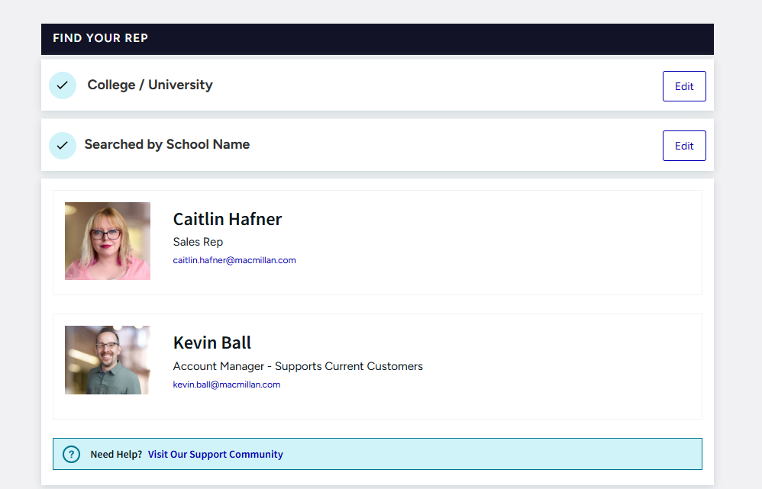

Personal Information
View Personal Info
Michael Winrow
Username: mawinrow@ecsu.edu
User ID: 2fdda2b6-ebba-11ec-9edc-ad01b7d298c4

